**Azad Kashmir:**

Red Fort

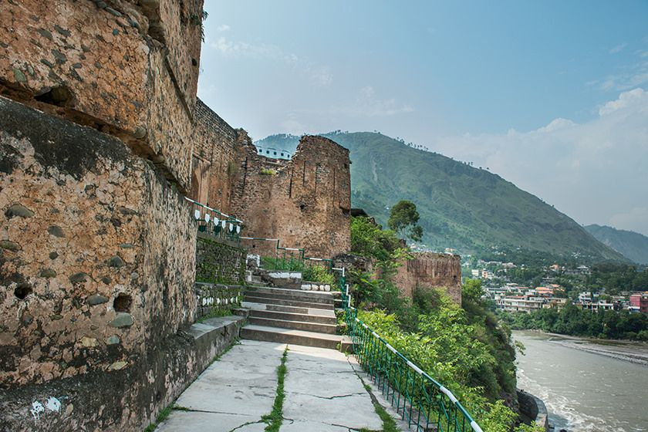

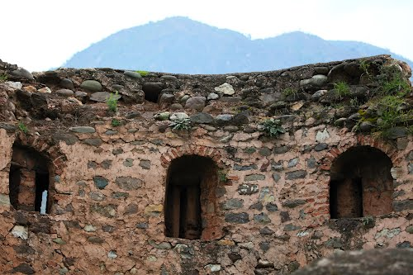

**Red Fort** - also known as the **Muzaffarabad Fort** was built by the Chak rulers of Kashmir in the 16th century. The current locality is called Center Plate. Locally, it is known as the "Rutta Qila" or just "qila".